CSI- 2K24
KSRMCE CSI Coordinators:
- B.Swetha, Assistant Professor, CSE Department
- A. Ramprakash Reddy, Assistant Professor, CSE Department
Computer Society of India (CSI) was first shown in the year 1965 with a handful of IT enthusiasts who were a computer user group and felt the need to organize their activities. They also wanted to share their knowledge and exchange ideas on what they felt were a fast emerging sector. Today the CSI takes pride in being the largest and most professionally managed association of and for IT professionals in India. The purposes of the Society are scientific and educational directed towards the advancement of the theory and practice of computer science and IT.
In KSRMCE, Computer Society of India (CSI) Student Branch has been started in Feb 2022. KSRMCE registered under Computer Society of India (CSI) Hyderabad Chapter.
KSRMCE CSI Student Branch, is celebrating the Foundation Day of “Computer Society of India” on 06 .03.2025 at KLM Auditorium, KSRM College of Engineering, Kadapa.
On this day Prize distribution is done for the students who are winners and runners in various events conducted during last one year i.e., 2024-25.

List Events organized during the year 2024-2025:
S.No | Event Name | Date | Participants
1. | Induction Program on CSI Awareness | 03.09.2024 | 720
2. | Carrer Catalyst 2k24 | 06.09.2024 | 150
3. | A Technical Fest “INNOVISION 2K24” | 13.09.2024 | 300
4. | Code Debugging | 04.10.2024 | 40
5. | Pen to Perfection | 05.10.2024 | 60
6. | 2 Days Workshop on  “ . Net Technologies” | 22.10.2024 to  23.10.2024 | 60
7. | Awareness Sessions on Cyber Hygiene Practices | 24.10.2024 | 300
8. | NextGen Coding-C++ Workshop | 28.10.2024 to  30.10.2024 | 50
9. | Python Leap: Taking the first steps in coding | 04.11.2024 to  06.11.2024 | 68
10 | A State Level Fest “INNOVATEX 2K24” | 14.11.2024 | 500
11 | One Day Workshop on Revolutionizing education: ChatGpt & QuillBot awareness workshop | 23.12.2024 | 150

Induction Program on CSI Awareness 03.09.2024

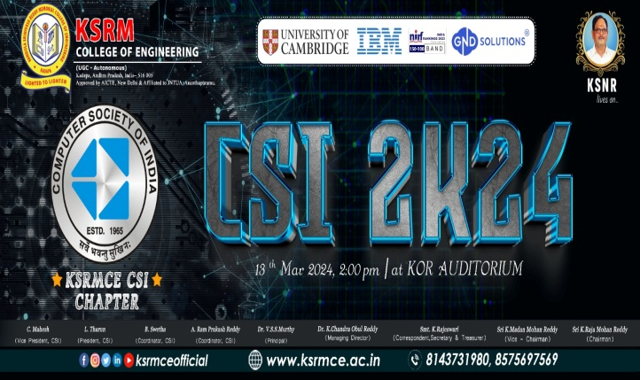 | 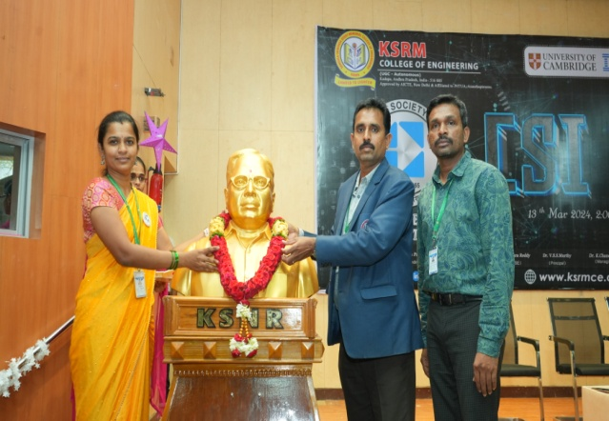
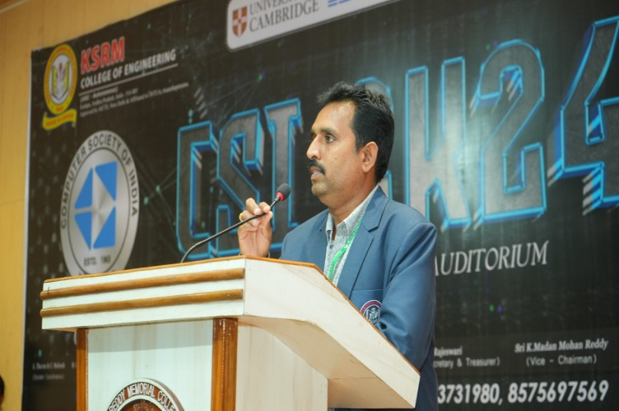 | 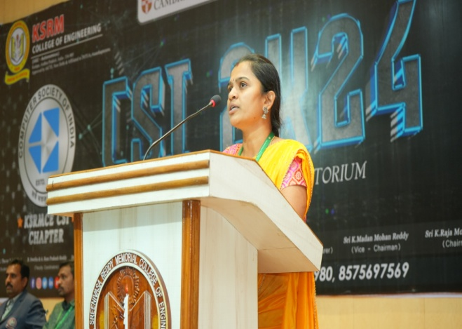
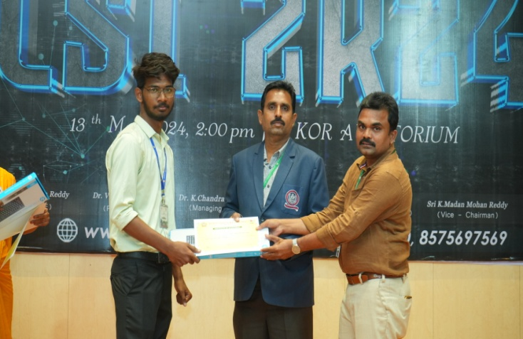 | 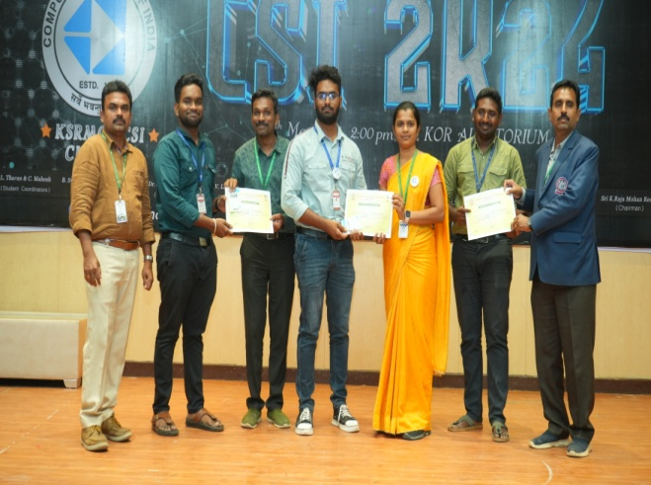
NextGen Coding-C++ Workshop 28.10.2024 to 30.10.2024

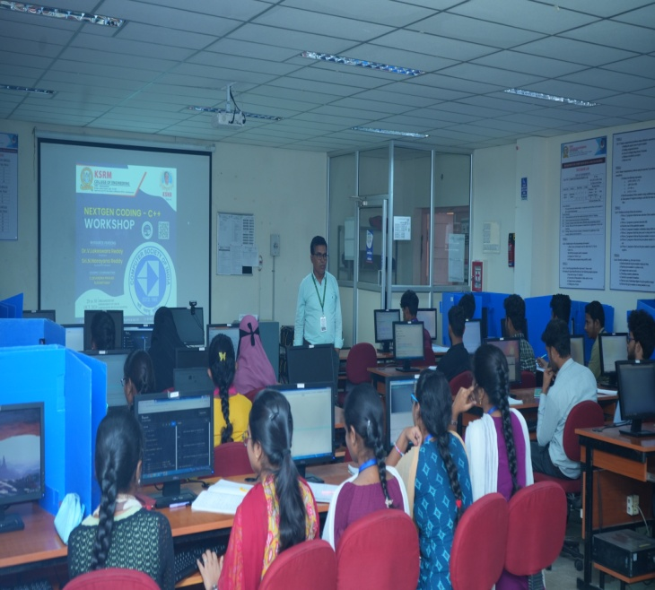 | 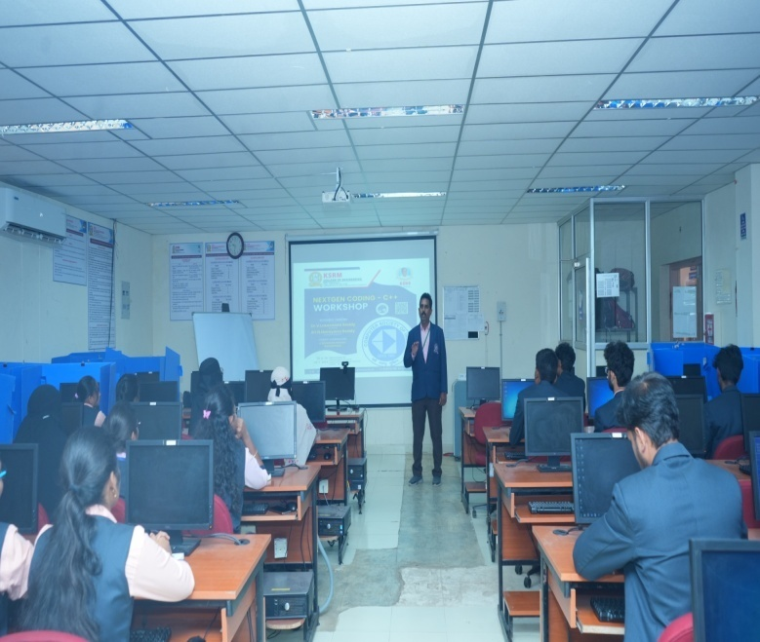
CARRER CATALYST-2K24 06.09.2024
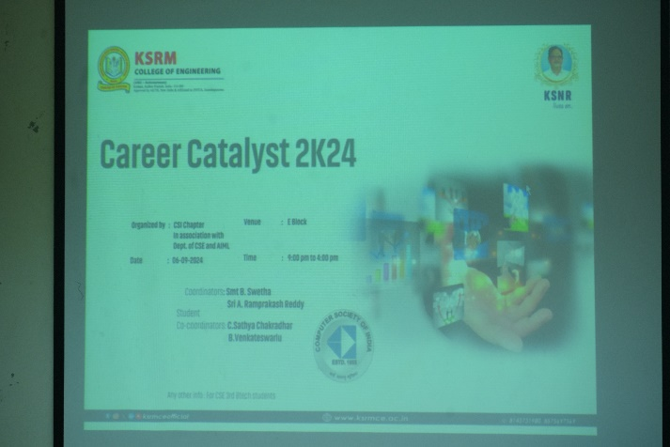 |  | 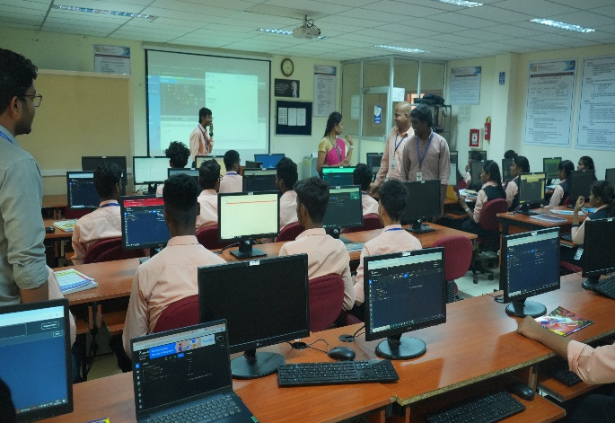
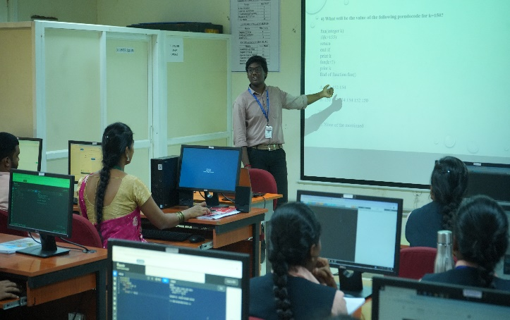 |  | 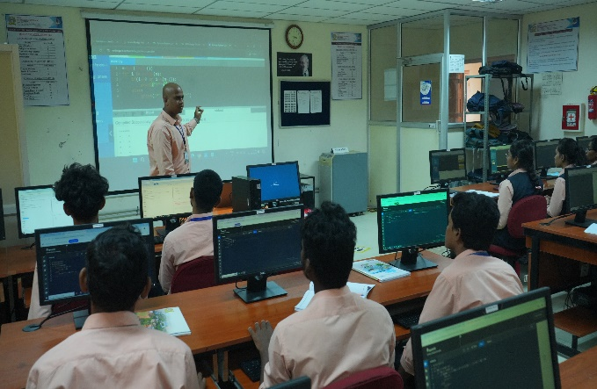

Pen to Perfection 05.10.2024
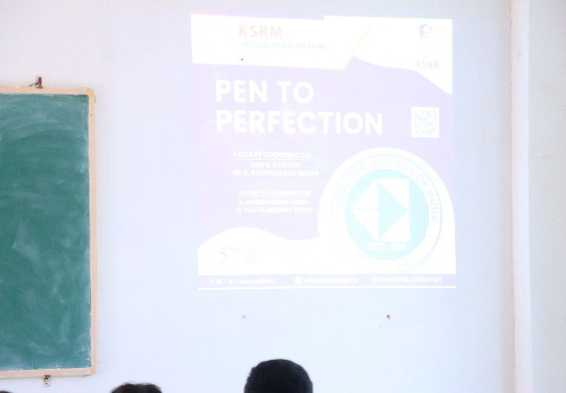 | 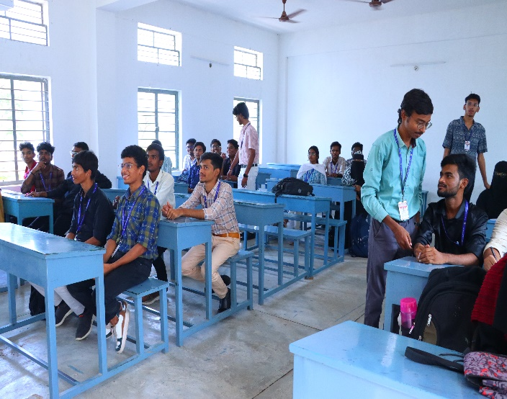
Code Debugging 04.10.2024

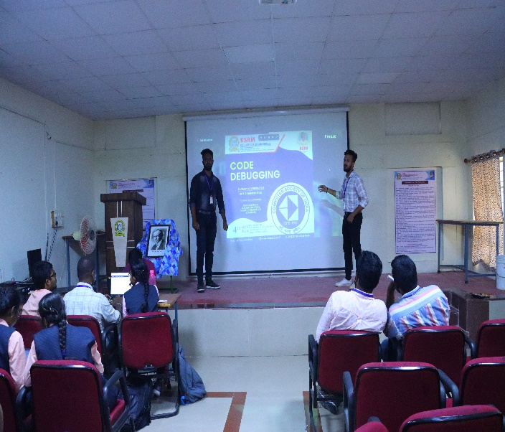 |  |  | 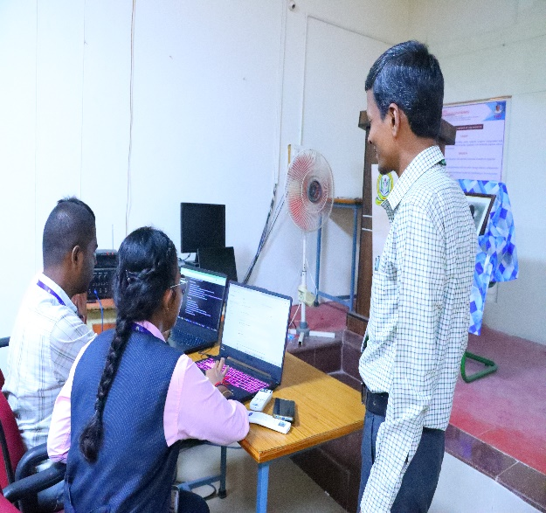
INNOVISION 2K24 13.09.2024

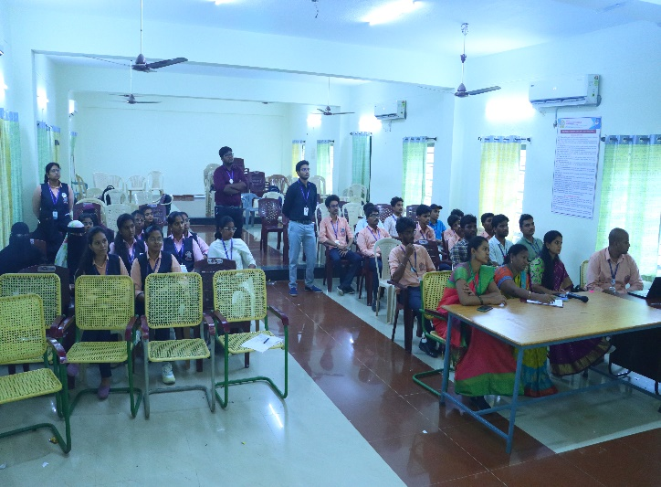 |  | 